# ID CARD GENERATION BOT

## A PROJECT REPORT

***Submitted by***

## ABHILASH A (220701004)

***in partial fulfillment for the course***

### OAI1903 - INTRODUCTION TO ROBOTIC PROCESS AUTOMATION

***for the degree of***

## BACHELOR OF ENGINEERING

***in***

**COMPUTER SCIENCE AND ENGINEERING**

## RAJALAKSHMI ENGINEERING COLLEGE RAJALAKSHMI NAGAR

**THANDALAM CHENNAI – 602 105**

**NOVEMBER 2023**

**RAJALAKSHMI ENGINEERING COLLEGE CHENNAI - 602105**

# BONAFIDE CERTIFICATE

Certified that this project report **“ID CARD GENERATOR BOT”** is the bonafide work of **“ABHILASH (220701004)”** who carried out the project work for the subject OAI1903 - Introduction to Robotic Process Automation under my supervision.

### Mrs.Jinu Sophia, M.E.,(Ph.D) SUPERVISOR

Assistant Professor (SG) Department of

Computer Science and Engineering Rajalakshmi Engineering College Rajalakshmi Nagar

Thandalam Chennai – 602105

Submitted to Project and Viva Voce Examination for the subject OAI1903 - Introduction to Robotic Process Automation held on .

**Internal Examiner External Examiner**

**ACKNOWLEDGEMENT**

Initially we thank the Almighty for being with us through every walk of our life and showering his blessings through the endeavour to put forth this report. Our sincere thanks to our Chairman **Mr. S.Meganathan, B.E, F.I.E.,** our Vice Chairman **Mr. Abhay Shankar Meganathan, B.E., M.S.,** and our respected Chairperson **Dr. (Mrs.) ThangamMeganathan, (Ph.D).,** for providing us with the requisite infrastructure and sincere endeavouring in educating us in their premier institution.

Our sincere thanks to **Dr. S.N.Murugesan, M.E., (Ph.D).,** our beloved Principal for his kind support and facilities provided to complete our work in time. We express our sincere thanks to **Dr. P.Kumar, M.E., (Ph.D).,** Professor and Head of the Department of Computer Science and Engineering for his guidance and encouragement throughout the project work. We convey our sincere and deepest gratitude to our internal guides, **Mrs.Jinu Sophia, M.E.,(Ph.D)** Assistant Professor (SG), Department of Computer Science and Engineering, Rajalakshmi Engineering College for their valuable guidance throughout the course of the project. We are very glad to thank our Project Coordinator **Dr.N.Durai Murugan M.E., (Ph.d.),** Professor and **Mr.B.Bhuvaneswaran, M.E.,** Assistant Professor (SG), Department of Computer Science and Engineering for his useful tips during our review to build our project.

ABHILASH A (220701004)

## ABSTRACT

This project automates the generation of ID cards using UiPath, addressing the challenges of manual ID card creation, such as time consumption, inconsistency, and errors. By leveraging robotic process automation (RPA), the system efficiently processes large datasets and produces professionally designed ID cards.

The project utilizes an Excel sheet as the data source, containing details such as employee names, unique IDs, departments, and photo paths. A pre-designed Word template serves as the layout for the ID cards, including placeholders for dynamic fields. The UiPath workflow reads data row by row from the Excel file, replaces the placeholders in the template with corresponding data, and generates the output in PDF or image format.

This approach eliminates the need for repetitive manual formatting, ensures accuracy, and produces consistent results. The system is highly scalable, capable of handling bulk data with minimal human intervention. Additionally, it offers flexibility, allowing template customization to meet organizational branding requirements.

This project showcases the potential of UiPath in automating administrative tasks, demonstrating how RPA can save time, reduce errors, and enhance productivity. It is an ideal solution for organizations requiring bulk ID card creation, such as schools, offices, and event management companies.

## TABLE OF CONTENTS

|  |  |  |
| --- | --- | --- |
| **CHAPTER NO.** | **TITLE** | **PAGE NO.** |
|  | **ABSTRACT** | **v** |
|  | **LIST OF FIGURES** | **vii** |
| **1.** | **INTODUCTION** | **1** |
|  | 1.1 INTRODUCTION | 11 |
|  | 1.2 OBJECTIVE | 12 |
|  | 1.3 EXISTING SYSTEM | 12 |
|  | 1.4 PROPOSED SYSTEM | 14 |
| **2.** | **LITERATURE REVIEW** | **15** |
| **3.** | **SYSTEM DESIGN** | **19** |
|  | 3.1 SYSTEM FLOW DIAGRAM | 19 |
|  | 3.2 ARCHITECTURE DIAGRAM | 20 |
|  | 3.3 SEQUENCE DIAGRAM | 21 |
| **4.** | **PROJECT DESCRIPTION** | **22** |
|  | 4.1 MODULES | 22 |
|  | * + 1. INPUT HANDLING AND INITIALIZATION     2. TEMPLATE PROCESSING | 22  22 |
|  | 4.1.3. OUTPUT AND NOTIFICATION | 23 |
| **5.** | **OUTPUT SCREENSHOTS** | **28** |
| **6.** | **CONCLUSION** | **29** |
|  | **APPENDIX** | **30** |
|  | **REFERENCES** | **31** |

**LIST OF FIGURES**

|  |  |  |
| --- | --- | --- |
| **Figure No.** | **Figure Name** | **Page No.** |
| 3.1 | System Flow Diagram | 16 |
| 3.2 | Architecture Diagram | 17 |
| 3.3 | Sequence Diagram | 18 |
| 5.1 | WORKFLOW | 21 |
| 5.2 | OUTPUT | 25 |

**CHAPTER 1 INTRODUCTION**

### INTRODUCTION

ID card generation is an essential administrative task for organizations such as schools, universities, offices, and event management companies. These cards are often used for identification, access control, and branding purposes. However, the traditional process of creating ID cards is highly manual, requiring human effort to input data, design the layout, and produce each card. This approach is not only time-consuming but also prone to errors, especially when dealing with large volumes of data. Mistakes in names, photos, or IDs can lead to significant issues, including a lack of professionalism and operational inefficiencies.

To address these challenges, this project introduces an automated ID card generation system using UiPath, a leading tool in Robotic Process Automation (RPA). The solution integrates Excel as the data source for storing and managing information and a Word document as the template for the ID card design. UiPath automates the process by dynamically replacing placeholders in the Word template with data from the Excel file. This ensures accurate, efficient, and consistent generation of ID cards, even when handling bulk data.

By leveraging automation, organizations can significantly reduce manual effort, save time, and eliminate errors, while also ensuring that ID cards are professional and uniform in design. This system is particularly beneficial for scenarios where hundreds or thousands of ID cards need to be generated within a short time frame.

.

### OBJECTIVE

The primary objective of this project is to develop an automated and efficient solution for generating ID cards that streamlines the traditionally manual process. The system is designed to read bulk data directly from an Excel sheet, which acts as a structured repository for information such as employee or student names, IDs, departments, and photo paths. This not only ensures scalability but also facilitates easy management of data. Using a pre-designed Word template, the system dynamically replaces placeholders within the template with the actual data extracted from the Excel sheet, ensuring each ID card is unique, accurate, and properly formatted. The final output is exported in professional formats, such as PDF or images, which makes them suitable for printing and distribution. By automating this process, the system achieves consistency and professionalism, making it an efficient tool for generating ID cards.

### EXISTING SYSTEM

In many organizations, the process of creating ID cards remains a manual task, which works for a small number of cards but becomes inefficient and error-prone as the volume of data increases. Manual data entry requires individuals to input information into an ID card template one by one, which can lead to errors such as typos, mismatches between names and photos, or missing data. Additionally, manually adjusting the layout and formatting of each card can be time-consuming, especially when generating a large number of cards. Each ID card requires individual attention, from aligning text to ensuring that photos fit within designated spaces. This is both labor-intensive and prone to human error. In addition to these challenges, the time-consuming nature of manual processes makes it unsuitable for modern environments, where fast-paced workflows demand efficiency. Given the increasing need to generate ID cards for hundreds or thousands of individuals, traditional manual methods are neither efficient nor scalable.

### PROPOSED SYSTEM

The The proposed system addresses the limitations of traditional methods by introducing automation to the ID card generation process. Built using UiPath, a leading Robotic Process Automation (RPA) tool, the system integrates seamlessly with Excel and Word to handle data processing and template customization. The system reads and processes data directly from an Excel file, eliminating the need for manual data entry. This automated approach reduces the risk of errors and significantly speeds up the process. A pre-designed Word template, with placeholders such as <Name>, <ID>, and <Photo>, is dynamically updated with information from the Excel sheet. This ensures that the generated ID cards are accurate and consistent. Furthermore, the system has a bulk processing capability, which allows it to handle multiple records simultaneously and generate ID cards in just a few seconds. This capability makes it ideal for organizations that need to create large volumes of ID cards efficiently. Once generated, the ID cards are outputted in professional formats like PDFs or images, providing a polished and uniform appearance. By automating the entire process, the proposed system significantly enhances both the efficiency and accuracy of ID card creation, reducing time spent and eliminating human errors. This system not only saves time and effort but also guarantees high-quality, consistent results, making it a valuable tool for any organization.

4o mini.

## CHAPTER 2 LITERATURE REVIEW

The **Automation in Administrative Processes**

Automation has emerged as an essential tool in optimizing administrative workflows, significantly reducing the burden on employees and enhancing overall productivity. Numerous studies have shown that automating repetitive tasks can drastically improve the efficiency of business operations. Administrative processes such as data entry, report generation, and document management often consume a substantial amount of time when handled manually. However, by automating these processes, organizations can free up their staff to focus on more strategic or high-priority tasks that require human intervention. For instance, automation can streamline processes like updating employee records, processing forms, or creating certificates and ID cards. By reducing the need for manual input, automation also minimizes human error, which is often seen in manual tasks, such as data inaccuracies, formatting issues, and typos. This leads to greater consistency and accuracy in the output. Automation can further improve the speed at which tasks are completed—repetitive tasks that would typically take hours to complete manually can now be done in minutes, saving valuable time and resources. In the case of bulk document generation, such as creating thousands of ID cards for an institution, automation ensures that each document follows the same high-quality standards while dramatically reducing the workload for administrative staff. As a result, businesses can handle larger datasets and improve their responsiveness in a fast-paced work environment. Overall, automation in administrative processes leads to higher operational efficiency, better resource utilization, and a reduction in costly errors.

The **Automation in Administrative Processes**

Automation has emerged as an essential tool in optimizing administrative workflows, significantly reducing the burden on employees and enhancing overall productivity. Numerous studies have shown that automating repetitive tasks can drastically improve the efficiency of business operations. Administrative processes such as data entry, report generation, and document management often consume a substantial amount of time when handled manually. However, by automating these processes, organizations can free up their staff to focus on more strategic or high-priority tasks that require human intervention. For instance, automation can streamline processes like updating employee records, processing forms, or creating certificates and ID cards. By reducing the need for manual input, automation also minimizes human error, which is often seen in manual tasks, such as data inaccuracies, formatting issues, and typos. This leads to greater consistency and accuracy in the output. Automation can further improve the speed at which tasks are completed—repetitive tasks that would typically take hours to complete manually can now be done in minutes, saving valuable time and resources. In the case of bulk document generation, such as creating thousands of ID cards for an institution, automation ensures that each document follows the same high-quality standards while dramatically reducing the workload for administrative staff. As a result, businesses can handle larger datasets and improve their responsiveness in a fast-paced work environment. Overall, automation in administrative processes leads to higher operational efficiency, better resource utilization, and a reduction in costly errors.

**UiPath and RPA**

UiPath, one of the leading platforms for Robotic Process Automation (RPA), has become a go-to solution for organizations looking to automate their repetitive and time-consuming tasks. UiPath offers a powerful suite of tools that enable businesses to automate tasks such as data extraction, document generation, and report processing. Its integration capabilities with common office applications like Excel and Word make it especially well-suited for document-centric processes, such as generating ID cards or invoices. With UiPath, data from Excel can be automatically fed into pre-designed Word templates, eliminating the need for manual data entry. This process is both time-efficient and error-free, as the system ensures that each piece of information is accurately placed within the template. UiPath’s workflow automation extends beyond simple data entry tasks; it can handle more complex operations like image processing, email communication, and file management, providing a comprehensive solution for business automation. Additionally, its visual programming interface allows both technical and non-technical users to create automation workflows without extensive coding knowledge. This accessibility makes it an ideal tool for organizations of all sizes. UiPath’s ability to scale means that it can handle both small tasks, such as generating a few ID cards, and large-scale processes, such as handling thousands of records in a corporate environment. The platform also provides a high level of customization, enabling businesses to fine-tune workflows to meet their specific needs. By automating repetitive tasks with UiPath, organizations can increase productivity, reduce human errors, and ensure consistency across various operations.

**Template-Based Document Generation**

The Template-based document generation has transformed the way businesses create and manage documents, particularly when dealing with high volumes of standardized outputs. This method allows organizations to design a template that contains fixed elements—such as logos, headings, and layout details—while leaving placeholders for dynamic data that can be automatically populated. The ability to use templates for generating documents has become increasingly popular in industries where high-quality, consistent outputs are needed, such as in the creation of ID cards, certificates, reports, and invoices. Template-based systems are incredibly effective for automating document creation as they offer a scalable solution that can handle large batches of documents in a short amount of time. For example, in the case of ID card generation, a template would include all the fixed elements like card design, text formatting, and branding, while placeholders would be used for variable data, such as employee names, department details, photos, and unique identification numbers. Once the template is set up, the system can automatically replace the placeholders with data from an external source, such as an Excel sheet, creating individual ID cards in seconds. This method eliminates the need for manual data entry and formatting adjustments, reducing the likelihood of human errors, such as misaligned text or inconsistent designs. Template-based document generation also ensures that all documents are uniform, meeting the organization’s branding guidelines and maintaining a high level of professionalism. Furthermore, since templates are pre-defined, it is easy to update and modify them whenever necessary, allowing organizations to quickly adapt to changing requirements without starting the design process from scratch. This scalability and flexibility make template-based document generation an ideal solution for industries that require mass document production.

## CHAPTER 3 SYSTEM DESIGN

### SYSTEM FLOW DIAGRAM

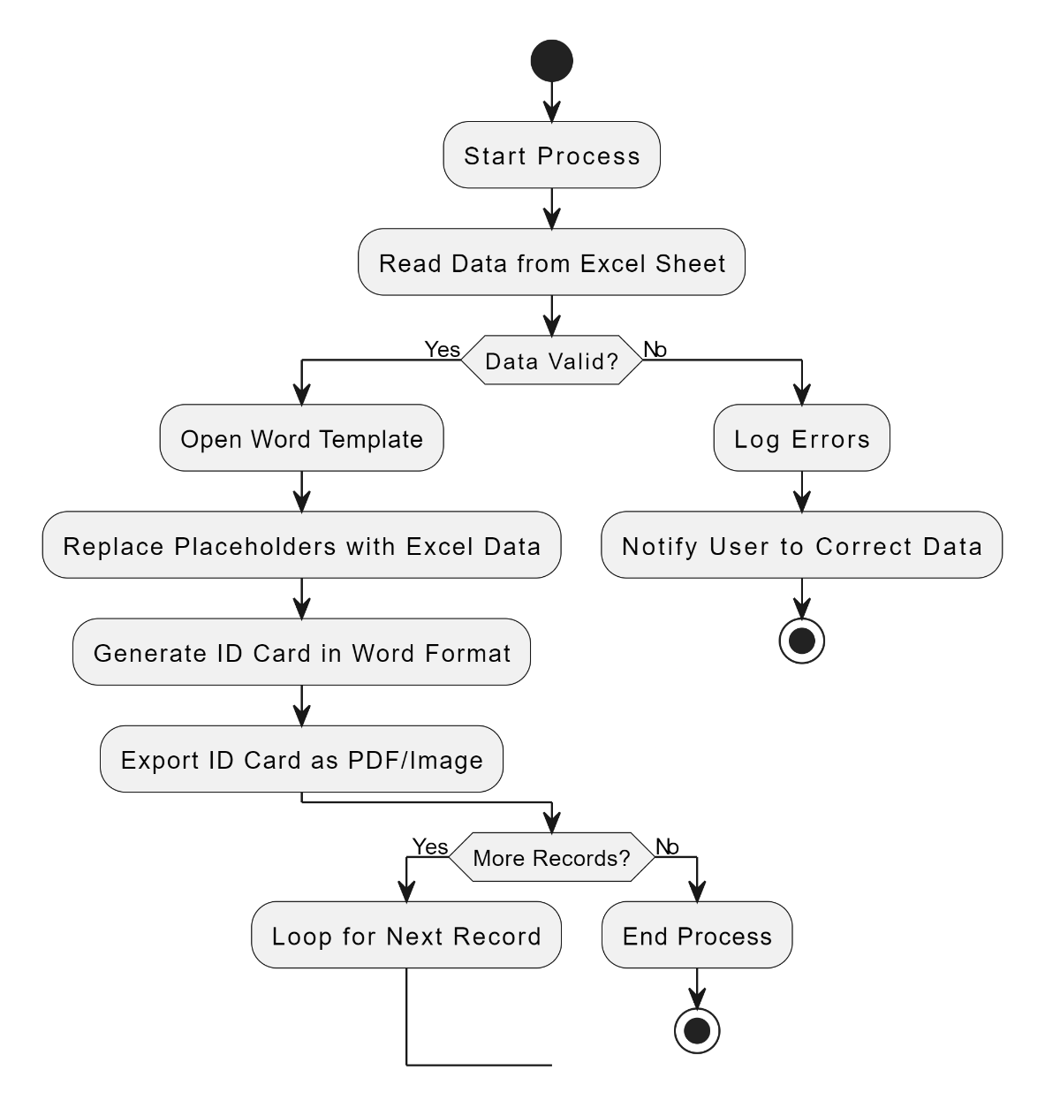

Fig 3.1 System Flow Diagram

A flowchart is a type of diagram that represents an algorithm, workflow or process. The flowchart shows the steps as boxes of various kinds, and their order by connecting the boxes with arrows. This diagrammatic representation illustrates a solution model to a given problem. The system flow diagram for this project is in Fig. 3.1.

### ARCHITECTURE DIAGRAM

An architecture diagram is a graphical representation of a set of concepts, that are part of an architecture, including their principles, elements and components. The architecture diagram for this project is in Fig. 3.2.

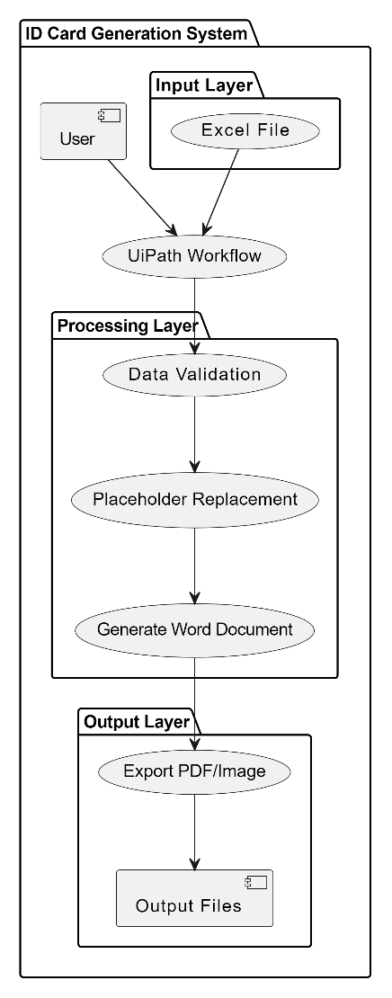

Fig 3.2 Architecture Diagram

### SEQUENCE DIAGRAM

Fig 3.3 Sequence Diagram

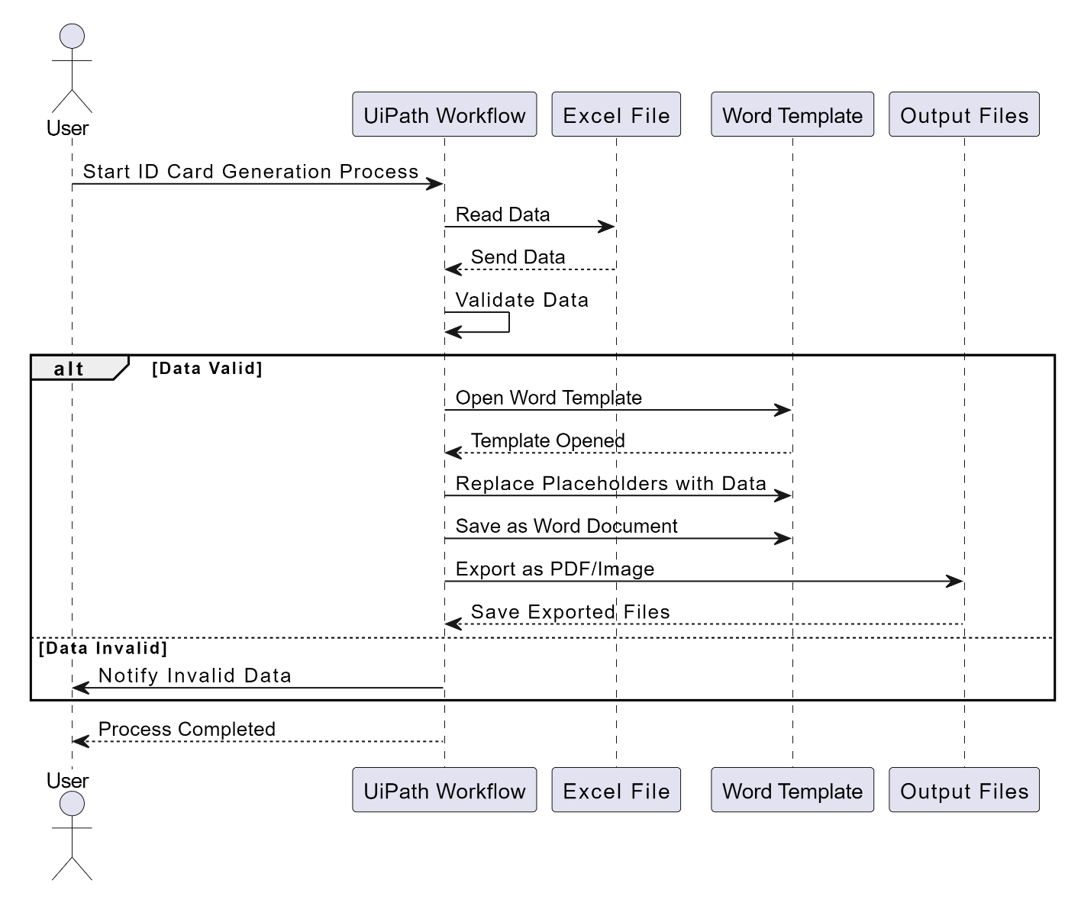Sequence diagram is a type of interaction diagram because it describe and show in what order a group of objects works together. The sequence diagram for this project is in Fig. 3.3.

## CHAPTER 4 PROJECT DESCRIPTION

The The ID Card Generation system is designed to automate the creation of professional ID cards by integrating Excel and Word functionalities through UiPath. It eliminates manual processes, reduces errors, and ensures efficiency in generating ID cards for organizations. The project is structured into three main modules, each playing a critical role in the workflow.

**4.1 Modules**

**4.1.1 Input Handling and Initialization**

The system begins by reading data from an Excel file, which serves as the source for all relevant information such as names, IDs, department details, and photo paths. Before processing, the data undergoes validation to ensure that all required fields are present and correctly formatted. This step guarantees data integrity, preventing issues such as missing or mismatched entries during ID card generation. The module also logs errors and alerts users if any discrepancies are detected, ensuring a smooth workflow.

**4.1.2 Template Processing**

This module manages the dynamic creation of ID cards by utilizing a pre-designed Word template. The template contains placeholders for details like the name, ID, department, and photo. The system dynamically replaces these placeholders with data from the validated Excel sheet. Advanced functionalities such as embedding photos or generating QR codes are also handled in this module. This ensures that each ID card is uniquely tailored while maintaining a consistent design. The module ensures accurate placement and formatting, adhering to organizational branding standards.

**4.1.3 Output and Notifications**

Once the ID cards are generated, the system exports them in professional formats such as PDF or image files, ready for printing and distribution. Each completed card is logged, creating a record for tracking purposes. Additionally, the system can send notifications or generate summary reports for stakeholders, providing updates on the process. This module ensures the final output is organized, easily accessible, and distributed to the relevant individuals.

These modules work cohesively to deliver a robust, efficient, and user-friendly solution for ID card generation.

**CHAPTER 5 WORKFLOW SCREENSHOT**

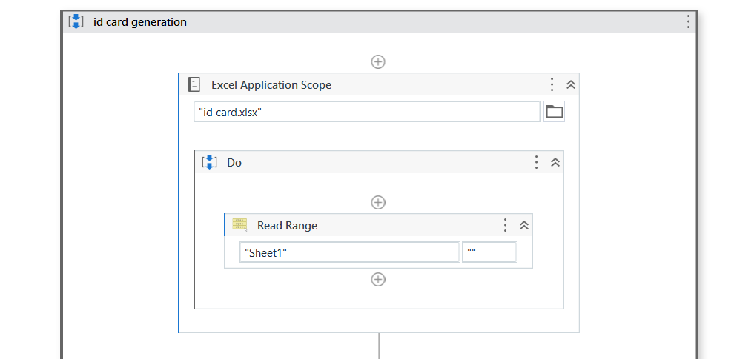

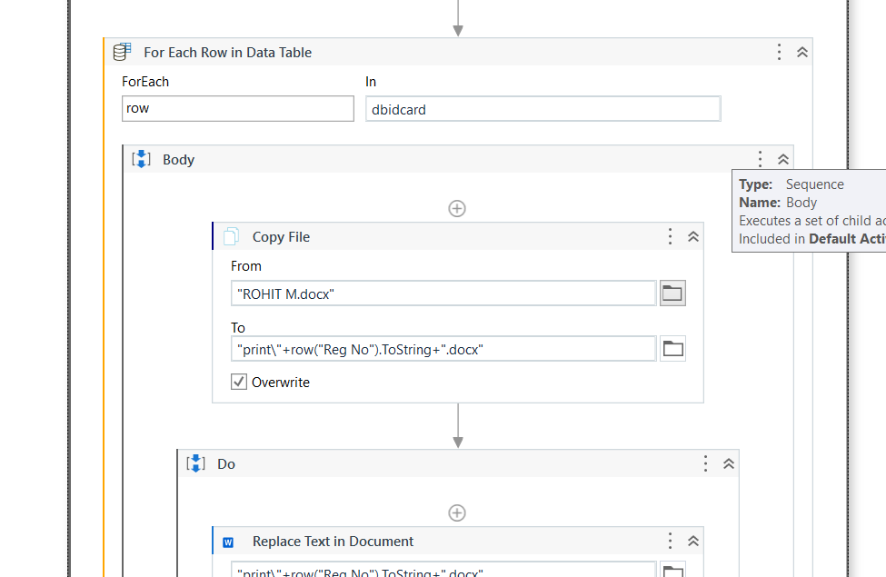

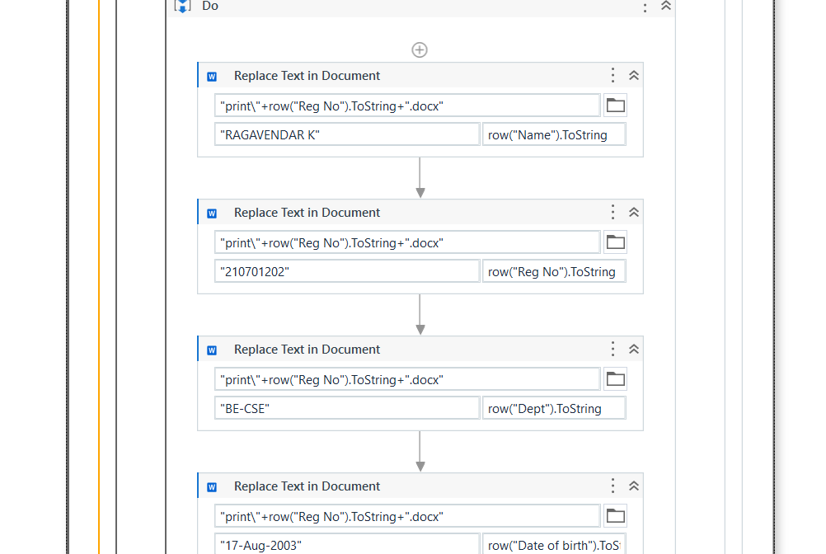

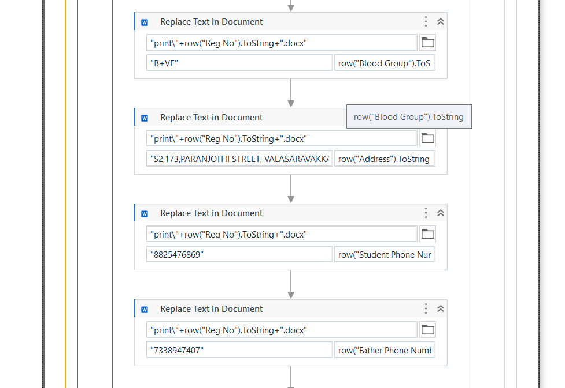

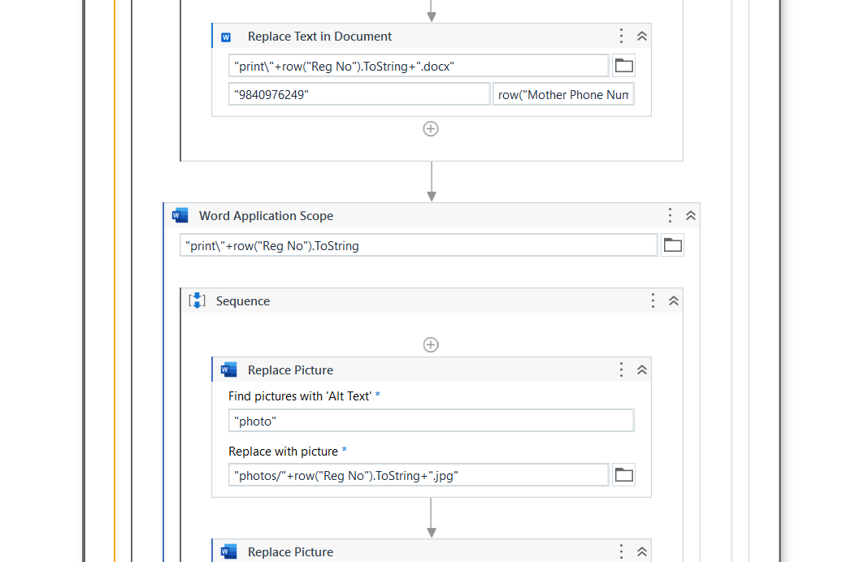

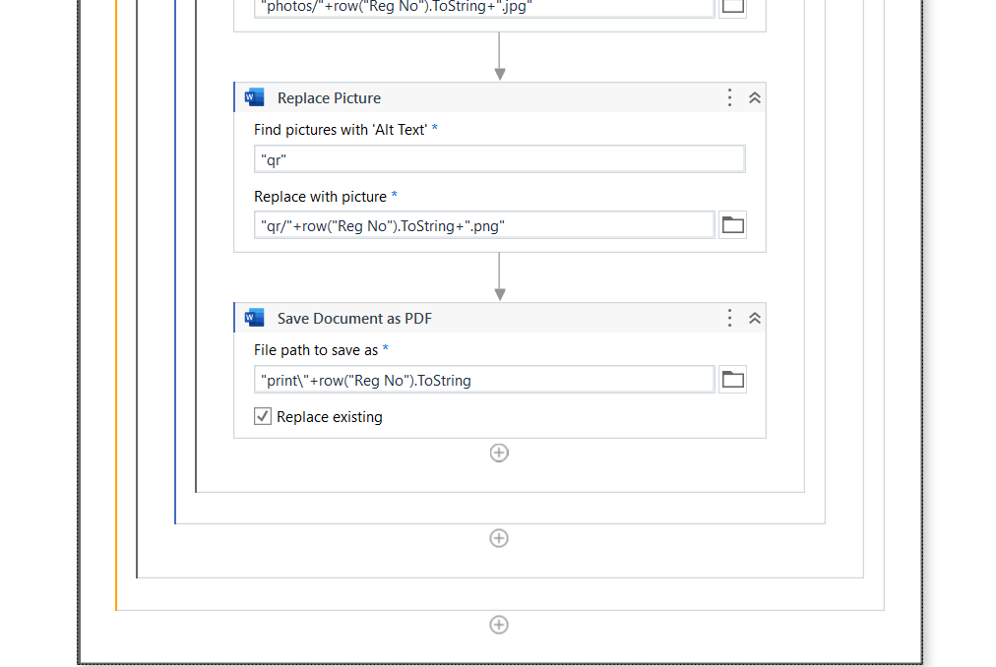

# OUTPUT SCREENSHOT

# 6

# 

## CHAPTER 6 CONCLUSION

The ID card generation system showcases how automation can simplify repetitive tasks, making them faster and more accurate. Traditionally, creating ID cards is a tedious process involving manual data entry, formatting, and verification, all of which are time-consuming and prone to mistakes. This project changes that by using UiPath to automate the workflow, seamlessly combining Excel for managing data and Word for designing the ID card template. The system dynamically fills placeholders in the template with information from the Excel file, ensuring that every card is accurate and consistent.

What sets this solution apart is its scalability—it can handle large amounts of data with ease, making it perfect for organizations of all sizes. Whether you’re producing ID cards for a small group or an entire institution, the system generates professional results quickly by exporting the cards as PDFs or images. This saves time, reduces errors, and boosts productivity.

Looking ahead, the system could be enhanced with cloud integration, allowing remote access and collaboration. Another exciting addition could be a real-time ID card preview feature, so users can see the design before finalizing it. These improvements would make the system even more versatile and valuable for modern workplaces.

**Appendix**

**A. Tools and Technologies Used**

1. UiPath Studio
   * Automation platform used for developing workflows to integrate Excel, Word, and output generation.
2. Microsoft Excel
   * Utilized for storing input data such as names, IDs, departments, and photo paths.
3. Microsoft Word
   * Used to design the ID card template with placeholders for dynamic data insertion.
4. PDF/Image Export Tools
   * Generates the final output files for ID cards in professional formats suitable for printing and distribution.

**B. Input File Structure**

The Excel file used in the project contains the following columns:

* Name: Full name of the individual.
* ID: Unique identifier (e.g., student ID or employee number).
* Department: The department or group the individual belongs to.
* Photo Path: File path to the individual’s photo.

**C. Word Template Structure**

* The Word template includes placeholders such as <Name>, <ID>, <Department>, and <Photo>.
* These placeholders are dynamically replaced with data from the Excel file during the automation process.

**D. Workflow Logic**

1. Data Extraction:
   * Read and validate data from the Excel file.
2. Template Processing:
   * Open the Word template.
   * Replace placeholders with the corresponding data.
3. Output Generation:
   * Save the ID cards in PDF or image format.
   * Log completed records.

**E.** Error Handling

* If errors are detected in the Excel data (e.g., missing fields or invalid photo paths), the system:
  + Logs the errors.
  + Notifies the user to correct the issues.

**F.** Sample Output

A sample ID card output (PDF or image format) demonstrates the consistency and professionalism of the design.

## REFERENCES

[1] International Journal of Research Publication and Reviews Journal homepage:www.ijrpr.comb ISSN 2582-7421

Generating Identity Card in RE Framework without Orchestrator

Queue using RPA UiPath

Sandhiya S, Asso. Prof. Mr. J. Jayapandian

https://ijrpr.com/uploads/V4ISSUE6/IJRPR14528.pdf.

[2] Step-by-Step: Building an Automated ID Card Generation System using Microsoft Power Virtual Agent

by PriyanshuSrivastav

https://techcommunity.microsoft.com/blog/educatordeveloperblog/step-by-step-building-an-automated-id-card-generation-system-using-microsoft-pow/3918257

[3] SIGSv2: Enhanced Student ID Generator and Management System

Conference paper @16 December 2020

pp 765–774

https://link.springer.com/chapter/10.1007/978-981-15-8354-4_75

[4] DIGITAL STUDENT ID CARD USING RFID TECHNOLOGY (DIGITAL INSTITUTE)

This paper explores the integration of RFID technology in digital student ID cards, highlighting advancements in ID card functionalities.

https://ijcrt.org/papers/IJCRT2309351.pdf